USER GUIDE
General:
- Use the handle to unlatch the screen, but not to lift the screen. Once unlatched, place your hand underneath the bottom bar or in the groove along the bottom bar to lift the screen.
- When raising or lowering the screen, do so from a central position on the bottom bar, rather than from the sides – it’ll provide smoother operation and keep the screen aligned in the side guides.
- Every three months or so, lubricate the side guides along the groove where the screen is inserted into the guides – use silicon spray CRC 808 or similar, available in your local hardware store and some supermarkets.

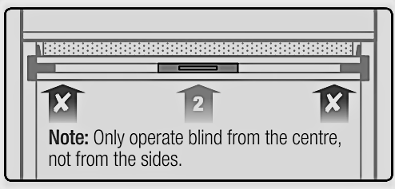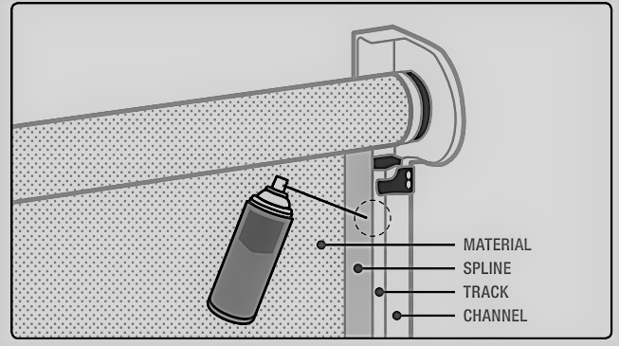

To get the best from your new Blinds:​​​
​​
- They should be rolled up only when clean and dry and Kept clean, IE Do not mow lawns or clean gutters, etc. with the PVC or fabric exposed.
- Do not leave them down in storms. Blinds can have large surface areas and are not designed to withstand storms. Always roll up the blind for strong winds.
- Do not leave rolled up for long periods of time. The longer it is rolled up, the longer it will take for the wrinkles to come out.
- Do not leave rolled up in direct sunlight. Heat can build up inside the roll, damaging the PVC. If roller is exposed a pelmet is recommended.
- In Summer: PVC tends to stretch and become quite supple depending on the direct contact time with the sun.
- In Winter: During the colder months PVC will contract and tighten up. Being rolled up for a long time in the rain can create white foggy marks when rolled down. Don't worry these will disappear in around a week or can be polished off using VuPlex (or similar).

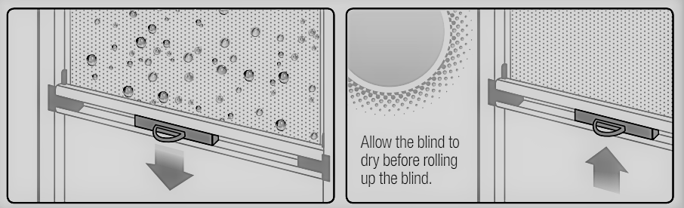

Cleaning Instruction PVC

- The use of harsh chemicals for cleaning should be avoided, as these can scratch the surface or attack the material.
- Clear PVC should only be cleaned with a diluted solution of mild soap and warm water. Rinse with clean water and dry with a soft cloth or a sponge.
- Do not use solvents or chemical cleaners. Do not expose sheets to abrasion. For handprint marks, methylated spirits may be used.
- We recommend Vuplex plastic cleaner/polish. Clean regularly by gently hose to remove loose dust. Follow the instructions on the can. Always allow to dry thoroughly before storage or re-use.

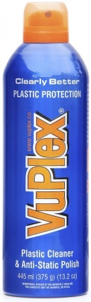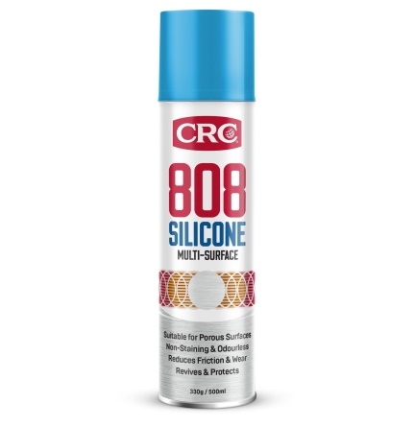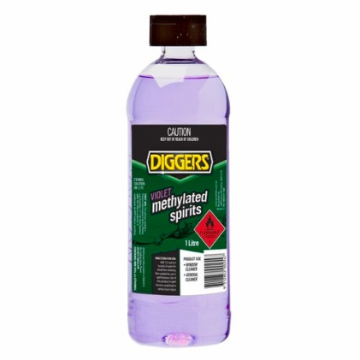

Vuplex plastic cleaner Silicon spray CRC 808 Methylated spirits

Rollerflex ASB Limited
Tel: 09 441 9455
Email: info@rollerflex.co.nz
Web: www.rollerflex.co.nz

