ROLLER BLINDS INSTALLATION GUIDE
1. INSIDE FIT
Positions of the brackets – TOP FIX
Place the brackets 10 mm inside from outer edge (figure 1) and fix each with 2 screws (6-8 gauge, 15 – 25 mm long). Be sure that both brackets are fixed on the same distance from outer/internal egde. You can place the bracket deeper inside of the frame to block more light but watch for handels or security stays to clear it. Same 10 mm rule applies if you place the brackets on internal edge of the window frame.
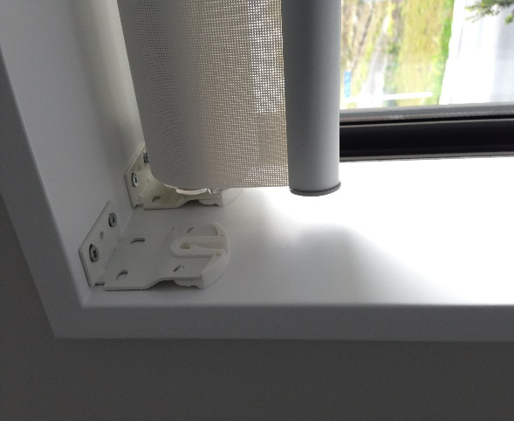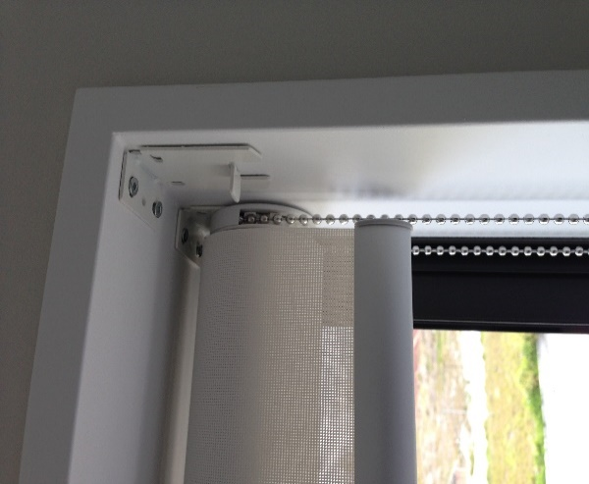
Figure 1 Figure 1
1. INSIDE FIT
Positions of the brackets – SIDE FIX
Place the brackets 10 mm inside from outer edge & 15 mm down from top seal (figure 2) and fix each with 2 screws (6-8 gauge, 15 – 25 mm long). Be sure that both brackets are fixed on the same distance from outer/internal egde. You can place the bracket deeper inside of the frame to block more light but watch for handels or security stays to clear it. If you want to install the brackets close to window (internal edge) you can istall them hard against the window joinery but keep it 15 mm down from top seal.
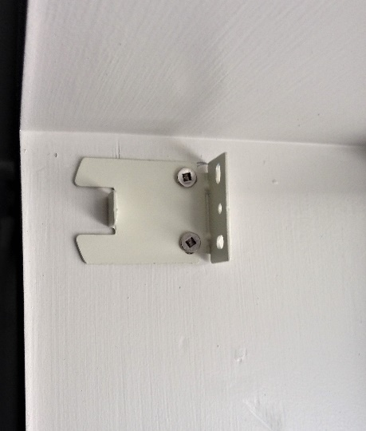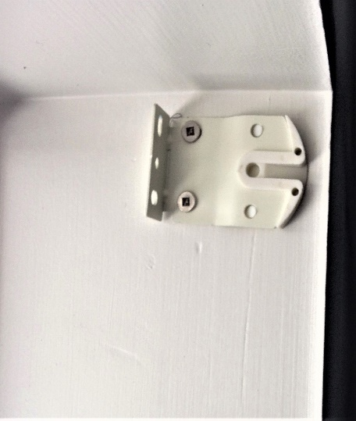
Figure 2 Figure 2

2. FACE FIT
Fix the bracket on a architrave or a wall (figure 3) with 2 – 3 screws (6-8 gauge, 15 – 50 mm long). Be sure that both brackets are on the same level and there is a solid fixing (wooden architrave, wall studs). Use giboard / wall plugs if you can’t fix the brakets the the wall studs.
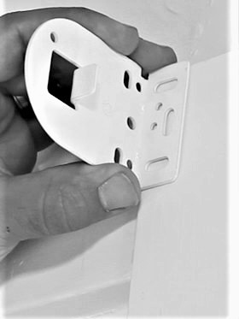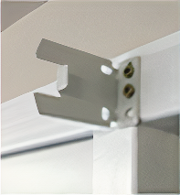
Figure 3 Figure 3
2. BLINDS FITTING
- Before you unpack your roller blind be sure that your hands are clean
- Turn the clear gear disc clockwise or anticlokwise to retract the pin (figure 4).

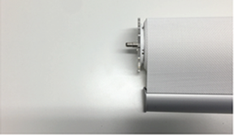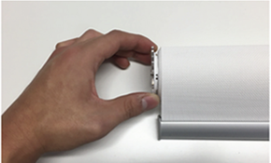
Figure 4 Figure 4

- Hold the blind so that the chain is hanging down correctly as shown (figure 5). That is the correct position for blind to operate.

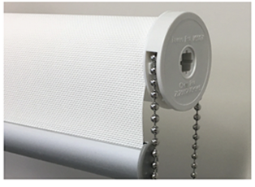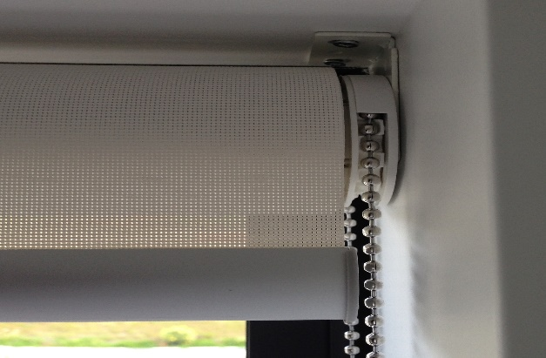
Figure 5 Figure 5

- Insert the chain end on to the tongue projecting out from the chain end bracket. Be sure that you insert winder (chain side of the blind) as is shown on figure 6.

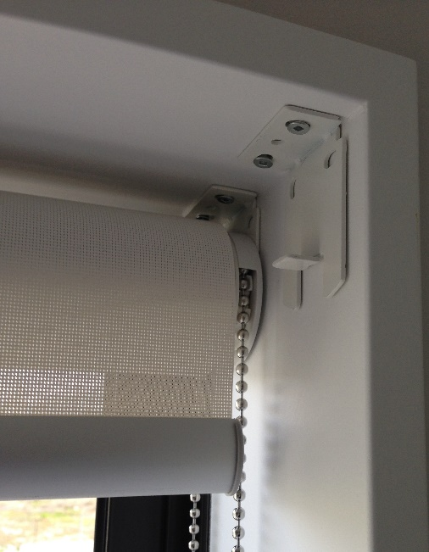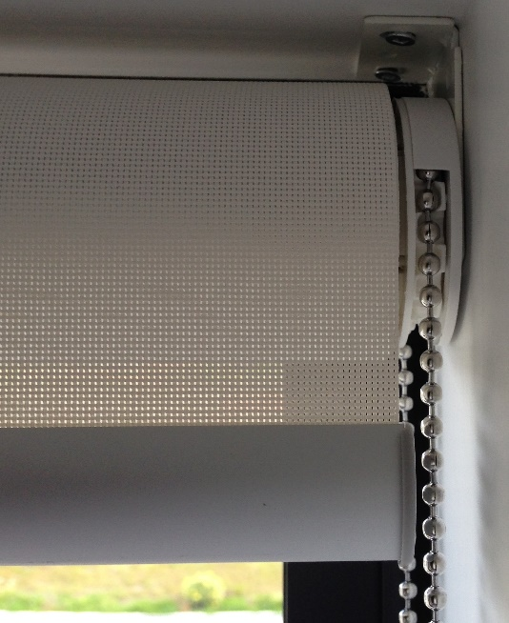
Figure 6 Figure 6

- Once the chain end is set correctly, slide in the pin end and reverse the gear disc to extend the pin into the bracket hole. Before you use it (pull the chain down), be sure that the pin is sitting corrctly inside of the hole.

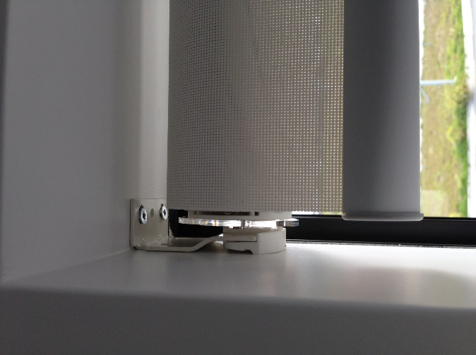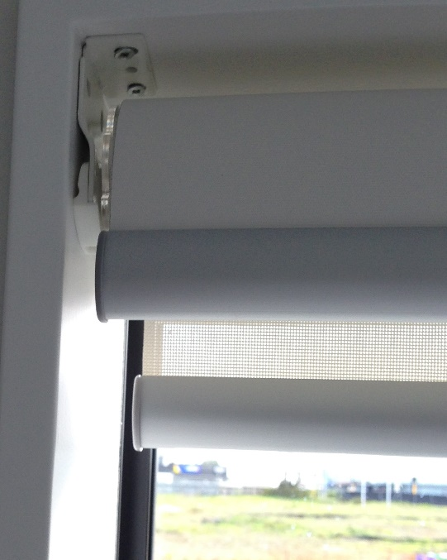
Figure 7 Figure 7

